Question Bank Booklet
& Practice Papers

English Language Paper 1

Oasis Academy Enfield

2020

Section A
Question 1 (Use sources A-F in order)

- Read again the first part of the source, from lines 1 to 5.
List four things about the motor-van from this part of the source.
[4 marks]

- Read again the first part of the source, from lines 1 to 9.
List four things about this jungle from this part of the source.
[4 marks]

- Read again the first part of the source, from lines 1 to 4.
List four things about Mr Fisher from this part of the source.
[4 marks]

- Read again the first part of the source, from lines 1 to 5.
List four things about Rosabel from this part of the source.
[4 marks]

- Read again the first part of the source from lines 1 to 5.

List four things about the bird in Alex’s nightmare from this part of the source. [4 marks]

- Read the first part of the Source, lines 1 to 7.

List four things from this part of the text about the weather in Cornwall. [4 marks]

Question 2 (Use Sources A-F in order)
Look in detail at this extract, from lines 6 to 12 of the source: (A)
Hartop was driving: a thin, angular man, starved-faced. He seemed to occupy almost all the seat, sprawling awkwardly; so that his wife and their daughter Alice sat squeezed up, the girl with her arms flat as though ironed against her side, her thin legs pressed tight together into the size of one. The Hartops’ faces seemed moulded in clay and in the light from the van-lamps were a flat swede-colour. Like the man, the two women were thin, with a screwed-up thinness that made them look both hard and frightened.
How does the writer use language here to describe the Hartop family?
You could include the writer’s choice of:
- words and phrases
- language features and techniques
- sentence forms.
[8 marks]

Look in detail at this extract, from lines 16 to 26 of the source: (B)
It came on great oiled, resilient, striding legs. It towered thirty feet above half of the trees, a great evil god, folding its delicate watchmaker’s claws close to its oily reptilian chest. Each lower leg was a piston, a thousand pounds of white bone, sunk in thick ropes of muscle, sheathed over in a gleam of pebbled skin like the armour of a terrible warrior. Each thigh was a ton of meat, ivory, and steel mesh. And from the great breathing cage of the upper body those two delicate arms dangled out front, arms with hands which might pick up and examine men like toys, while the snake neck coiled. And the head itself, a ton of sculptured stone, lifted easily upon the sky. Its mouth gaped, exposing a fence of teeth like daggers. Its eyes rolled, ostrich eggs, empty of all expression save hunger. It closed its mouth in a death grin. It ran, its pelvic bones crushing aside trees and bushes, its taloned feet clawing damp earth, leaving prints six inches deep wherever it settled its weight.
How does the writer use language here to describe the Tyrannosaurus Rex?
You could include the writer’s choice of:
- words and phrases
- language features and techniques
- sentence forms.
[8 marks]

Look in detail at this extract, from lines 9 to 15 of the source: (C)
Mr Fisher remembered a time – surely, not so long ago – when books were golden, when imaginations soared, when the world was filled with stories which ran like gazelles and pounced like tigers and exploded like rockets, illuminating minds and hearts. He had seen it happen; had seen whole classeswept away in the fever. In those days, there were heroes; there were dragons and dinosaurs; there were space adventurers and soldiers of fortune and giant apes. In those days, thought Mr Fisher, we dreamed in colour, though films were in black and white, and good always triumphed in the end.
How does the writer use language here to convey Mr Fisher’s views on books and stories of the past?
You could include the writer’s choice of:
- words and phrases
- language features and techniques
- sentence forms
[8 marks]

Look in detail at this extract, from lines 6 to 14 of the source: (D)
Rosabel looked out of the windows; the street was blurred and misty, but light striking on the panes turned their dullness to opal and silver, and the jewellers' shops seen through this were fairy palaces. Her feet were horribly wet, and she knew the bottom of her skirt and petticoat would be coated with black, greasy mud. There was a sickening smell of warm humanity – it seemed to be oozing out of everybody in the bus – and everybody had the same expression, sitting so still, staring in front of them. Rosabel stirred suddenly and unfastened the two top buttons of her coat… she felt almost stifled. Through her half-closed eyes, the whole row of people on the opposite seat seemed to resolve into one meaningless, staring face.
How does the writer use language here to describe Rosabel’s bus journey home?
You could include the writer’s choice of:
- words and phrases
- language features and techniques
- sentence forms.
[8 marks]

Look in detail at this extract from lines 6 to 11 of the source: (E)

What had awakened him was the noise from the storm: wind lashing the trees, rain on the rooftop, and thunder. He turned on the light with a sensation of being adrift in a boat, and pushed closer to the bulk of the large dog sleeping beside him. He pictured the roaring Pacific Ocean a few blocks from his house, spilling in furious waves against the rocks. He lay listening to the storm and thinking about the black bird and about his mother, waiting for the pounding in his chest to die down. He was still tangled in the images of his bad dream.
How does the writer use language here to describe the effects of the storm?
You could include the writer’s choice of:
• words and phrases
• language features and techniques
• sentence forms.
(Total 8 marks)

Look in detail at the extract from lines 8 to 17 of the Source: (F)

How does the writer use language here to describe the effects of the weather?
You could include the writer’s choice of:
• words and phrases
• language features and techniques
• sentence forms.
(Total 8 marks)

Question 3 (Sources A-F in order)

You now need to think about the whole of the source. (A)
This text is from the beginning of a short story.
How has the writer structured the text to interest you as a reader?
You could write about:
- what the writer focuses your attention on at the beginning of the source
- how and why the writer changes this focus as the source develops
- any other structural features that interest you.
[8 marks]

You now need to think about the whole of the source. (B)
This text is from the middle of a short story.
How has the writer structured the text to interest you as a reader?
You could write about:
- what the writer focuses your attention on at the beginning of the source
- how and why the writer changes this focus as the source develops
- any other structural features that interest you.
[8 marks]

You now need to think about the whole of the source. (C)
This text is from the beginning of a short story.
How has the writer structured the text to interest you as a reader?
You could write about:
- what the writer focuses your attention on at the beginning of the source
- how and why the writer changes this focus as the source develops
- any other structural features that interest you.
[8 marks]

You now need to think about the whole of the source. (D)
This text is from the beginning of a short story.
How has the writer structured the text to interest you as a reader?
You could write about:
- what the writer focuses your attention on at the beginning of the source
- how and why the writer changes this focus as the source develops
- any other structural features that interest you.
[8 marks]

You now need to think about the whole of the source. E
This text is taken from the beginning of a novel.
How is the text structured to interest you as a reader?
You could write about:
• what the writer focuses your attention on at the beginning
• how and why the writer changes this focus as the source develops
• any other structural features that interest you.
(Total 8 marks)

You now need to think about the whole of the Source. (F)
This text is from the opening of a novel.
How has the writer structured the text to interest you as a reader?
You could write about:
• what the writer focuses your attention on at the beginning
• how and why the writer changes this focus as the extract develops
• any other structural features that interest you.
(Total 8 marks)

Question 4 (Sources A-F)

Focus this part of your answer on the second part of the source A from line 34 to the end.
A student said, ‘This part of the story, where Alice is sent back along the road to find what has fallen from the roof and returns with the chrysanthemums, shows how hard and cruel Hartop is, so that all of our sympathy is with Alice.’
To what extent do you agree?
In your response, you could:
- consider whether Alice is treated cruelly by her father
- evaluate how the writer creates sympathy for Alice
- support your response with references to the text.
[20 marks]

Focus this part of your answer on the second part of the source B from line 31 to the end.
A student said, ‘This part of the story, where the men encounter the Tyrannosaurus Rex, shows Eckels is right to panic. The Monster is terrifying!’
To what extent do you agree?
In your response, you could:
- consider your own impressions of Eckels’ reaction to the Tyrannosaurus Rex
- evaluate how the writer describes the Monster
- support your response with references to the text.
[20 marks]

Focus this part of your answer on the second part of the source C from line 25 to the end.
A student said, ‘This part of the story, where Mr Fisher is marking homework, shows Tibbet’s story is better than Mr Fisher expected, and his reaction is extreme.’
To what extent do you agree?
In your response, you could:
- consider your own impressions of what Mr Fisher expected Tibbet’s homework to be like
- evaluate how the writer conveys Mr Fisher’s reaction to what he discovers
- support your response with references to the text.
[20 marks]

Focus this part of your answer on the second part of the source D from line 19 to the end.
A student said, ‘This part of the story, set in the hat shop, shows that the
red-haired girl has many advantages in life, and I think Rosabel is right to be angry.’
To what extent do you agree?
In your response, you could:
- consider your own impressions of the red-haired girl
- evaluate how the writer conveys Rosabel’s reactions to the red-haired girl
- support your response with references to the text.
[20 marks]

Focus this part of your answer on the second half of the source E from line 16 to the end.
A student said ‘This part of the story, set during breakfast time, shows that Alex is struggling to cope with his mother’s illness.’
To what extent do you agree?
In your response, you could:
• consider your own impressions of Alex
• evaluate how the writer shows that Alex is struggling to cope
• support your response with references to the text.
(Total 20 marks)

Focus your answer on the second half of the Source F, from line 18 to the end.
A student, having read this section of the text said: “The writer brings the very different characters to life for the reader. It is as if you are inside the coach with them.”
To what extent do you agree?
In your response, you could:
• write about your own impressions of the characters
• evaluate how the writer has created these impressions
• support your opinions with quotations from the text. (Total 20 marks)
Section B
Question 5

Your school or college is asking students to contribute some creative writing for its website.
Either
Describe a market place as suggested by this picture:
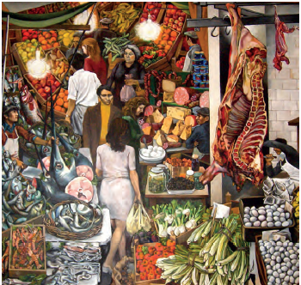
or
Write a story with the title ‘Abandoned’.
Your school or college is asking students to contribute some creative writing for its website.

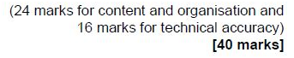

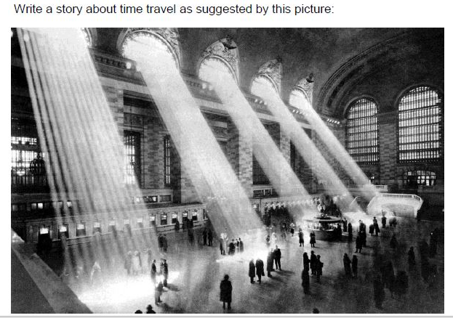

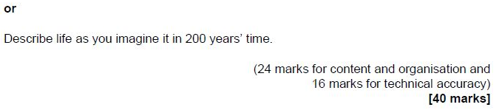

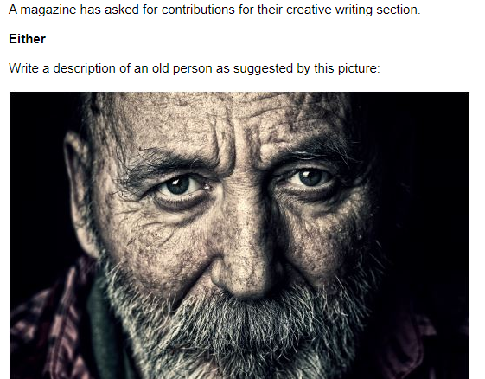

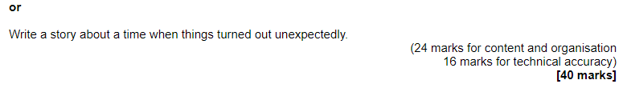

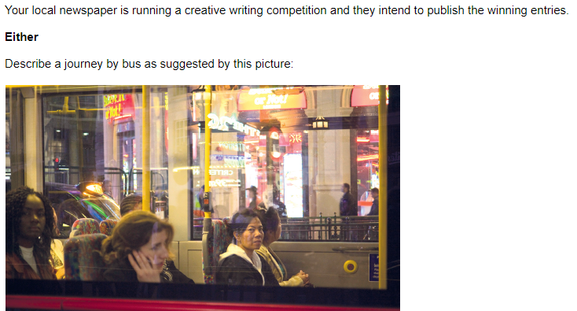

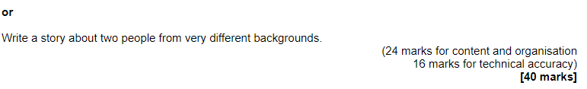

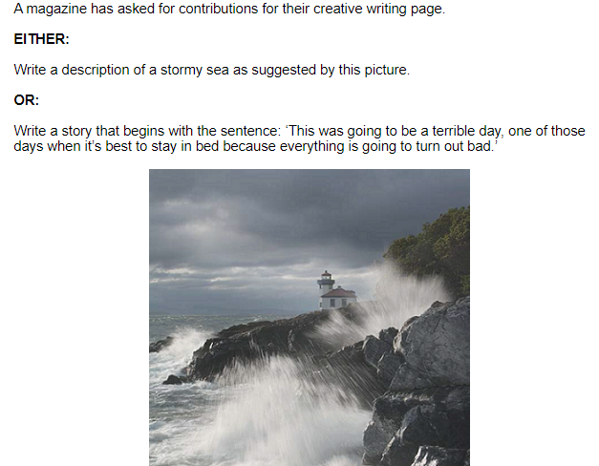

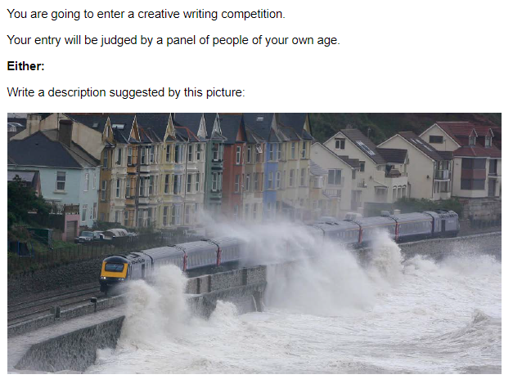

Sources: The following six sources need to be used in conjunction with the questions above.
Source A
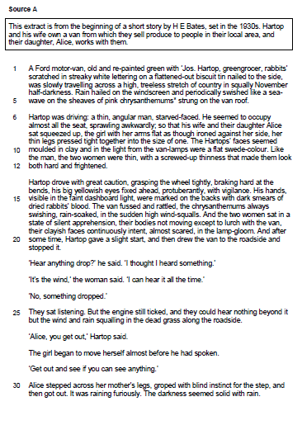
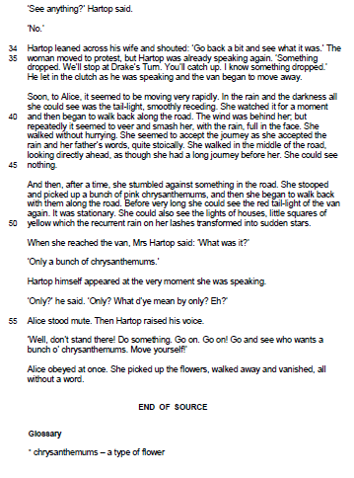

Source B

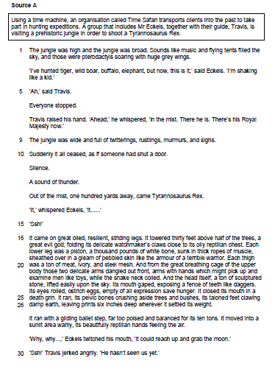

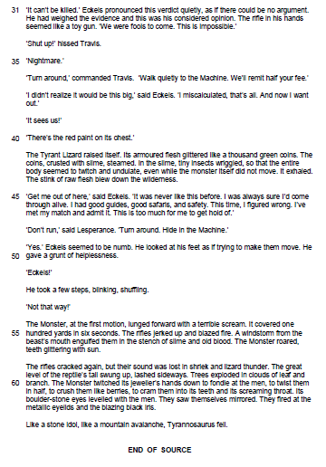

Source C

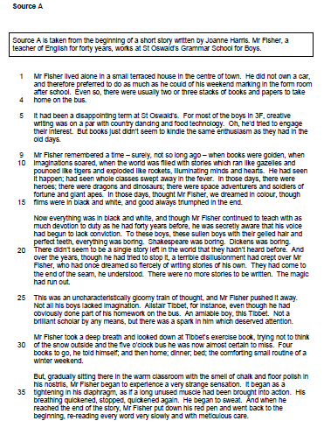

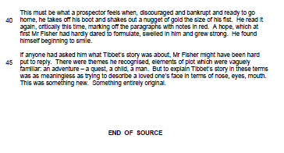

Source D

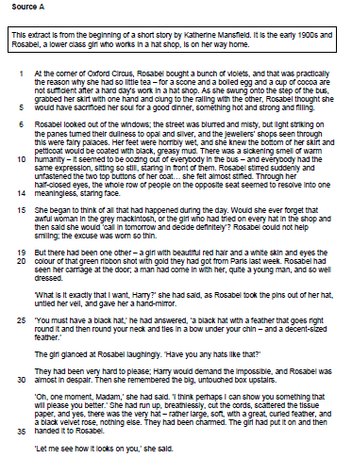

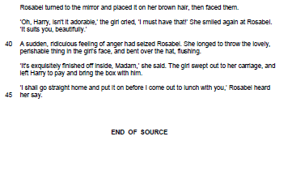

Source E

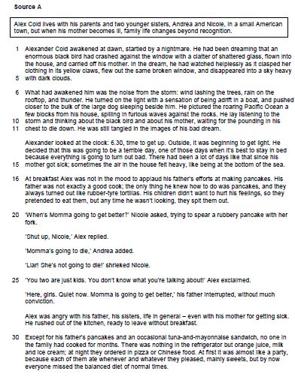

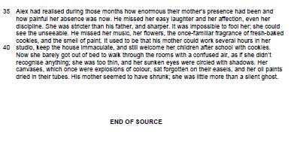

Source F

